System Requirement Specifications

**Table of Contents**

1. **Introduction2**

**1.1 Project Purpose**2

**1.2 Document Conventions**2

**1.3 Intended Audience**…………………………………………………………………………………….... 2

**1.4 Project Scope**………………………………………………………………………………………………. 2

**2. Description 3**

**2.1 Project Perspective**3

**2.2 Product Features**4

**2.3 User Class and Characterization**…………………………………………………………………. 6

**2.4 Operating Environment**……………………………………………………………………………… 6

**2.5 Design and Implementation Constraints**……………………………………………………. 6

**3. Interface Requirements**…………………………………………………………………………………………………. **7**

**3.1 User Interface**……………………………………………………………………………………………… 7

**3.2 Hardware Interface…………………………………………………………………………………..** 7

**3.3 Software Interface…………………………………………………………………………………….** 7

**4. Nonfunctional Requirements**…………………………………………………………………………………………. **7**

**4.1 Security Requirements**……………………………………………………………………………….. 7

**4.2 Hazard Risk………………………………………………………………………………………………** 8

**I Introduction**

**1.1 Project Purpose**

The purpose of this product is to provide customers with a solution to handle items airports will not allow. We want to guarantee safety and quickness when handling items.

**1.2 Document Conventions**

|  |
| --- |
| DB                                                                       Database |
| DDB                                                                    Distributed Database |
| SM                                                                       Site Map |

**1.3 Intended Audience**

This project is intended for customers at specified airports. This will be implemented by the stakeholders for customer use. This system will be useful for anyone within the airport.

**1.4 Project Scope**

The purpose of the shipping and storage system is to give customers an easier time when it comes to flying. The system will handle the occasions where customers may lose an item due to a TSA ban and ensure its safety until it is back in the customer's care. This will also help airports during the scanning process because it will allow customers to have items on the no flight list shipped or stored beforehand.

**II Description**

**2.1 Product Perspective**

The shipping and storage system will store information such as:

**Customer Information:**

This will include customer shipping information as well as items shipped or stored with the company using the airport kiosk.

**Order Information:**

This will include customer orders as well as tracking for up to date information on a customer’s item arrival time.

**Storage Information:**

This will include the items placed into storage, dates in which the item can be held as well as payments for storage use.

**2.2 Product Features**

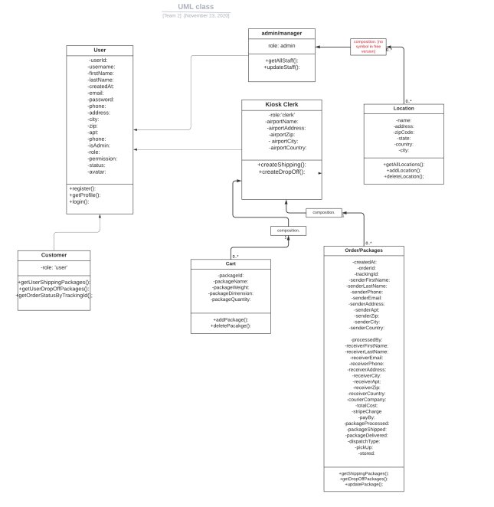

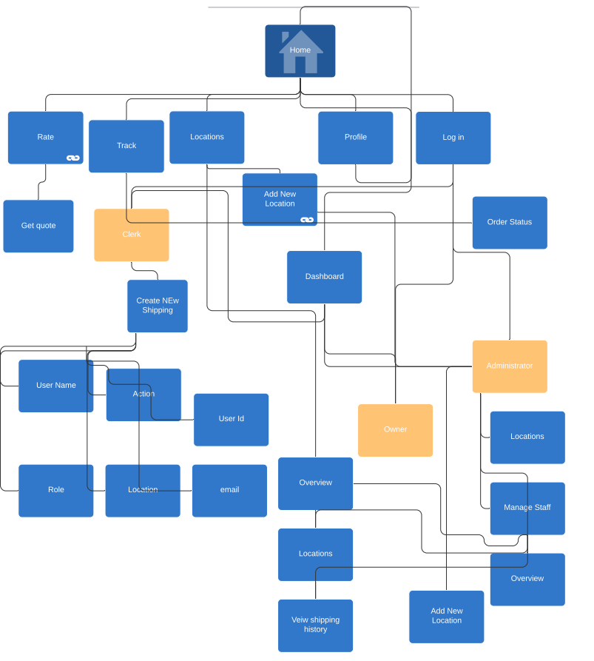

**2.3 User Class and Characteristics**

Customers using the system will be able to manage their orders on items shipped and stored and make payments on storage and shipping. The user should be able to track their order or storage status while it is in the care of the company. The system includes the following functions:

Customer Functions:

* Track orders using auto generated tracking number
* Make payments on items through system
* Cancel an item shipping or storage
* Create a support ticket

Employee Functions:

* Create an order for customers
* Track customer orders using the auto generated tracking number
* Cancel or modify existing orders for customers
* Handle support tickets processed

Admin Functions:

* Add/Archive airport kiosk location
* Onboard/Offboard incoming employees
* Update pricing for shipping and storage
* Create/Modify shipping and storage conditions

**2.4 Operating Environment**

Database: MongoDB

Platform: Visual Studio Code, React/JavaScript

**2.5 Design and Implementation Constraints**

There were no constraints placed by the stakeholder, but we remained on HTML/CSS, NodeJS, MongoDB, JavaScript, React and Visual Studio Code.

**III Interface Requirements**

**3.1 User Interface**

Front-end software: HTML/CSS, Visual Studio Code

Back-end software: NodeJS MongoDB, JavaScript

**3.2 Hardware Interface**

Any web browser or the airport kiosk

**3.3 Software Interface**

HTML/CSS was used due to its versatility among multiple web devices.

MongoDB was used due to the programming language being in JavaScript.

**IV Nonfunctional Requirements**

**4.1 Security Requirements**

User authentication is done through the use of cookies. Access to the database is done through specified key usage only given to admin or managers. Stripe is used to protect user card information.

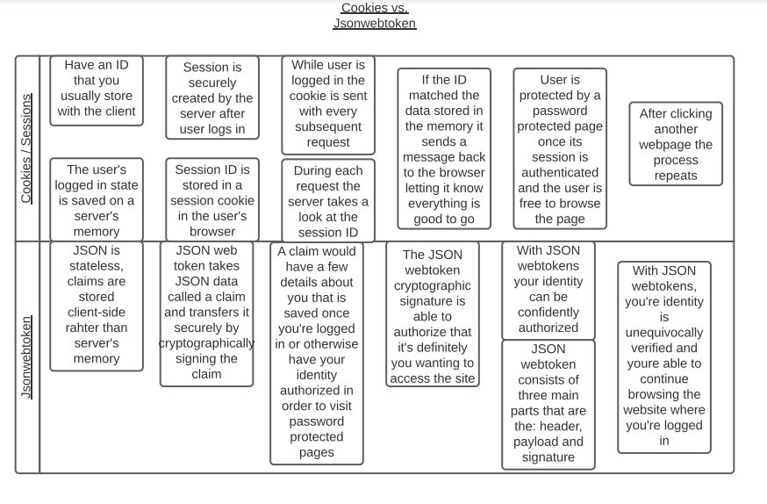

**4.2 Hazard Risk**

|  |  |  |  |  |
| --- | --- | --- | --- | --- |
| Identified Hazard | Hazard Probability | Accident Severity | Estimated Risk | Acceptability |
| 1. Product Damage | Medium | Low | Medium | ALARP |
| 2. Product Loss | Low | Low | Medium | ALARP |
| 3. Customer Information Leak | Low | High | High | Intolerable |
| 4. Website Crash | Low | Low | Medium | ALARP |
| 5. No label Occurrence | Low | Low | Low | Intolerable |